**Brief Guide**

**to**

**PRAGUE**

### Phone numbers:

112 – Integrated emergency services

150 – Fire brigade

155 – Medical emergency

158 – Police

### Money etc.

In Prague it is common to pay with a card, so you don’t need big amount of cash. On the other hand small enterprises don’t accept cards so appropriate amount of cash is advisable. ATM machines are plentiful. Exchange offices are generally expensive and some try to cheat, we’d rather use the ATMs.

## Getting around

#### Driving

Driving in Prague is similar to any other metropolis – waiting in a traffic jam and difficult to park. Therefore it’s mostly not worth to drive anywhere in Prague, better to use public transport instead. Its network is cheap, dense, reliable and relatively comfortable. However if you still want to come by car, you should know something about parking.

#### Parking

**To park your vehicle in Prague is a virtually impossible task and the circumstances are very confusing!** Even though you find a vacant spot, you have to consider characteristics of that particular place. There are parking zones in inner parts of the city which are restricted only for residents (marked by a blue line on the pavement).

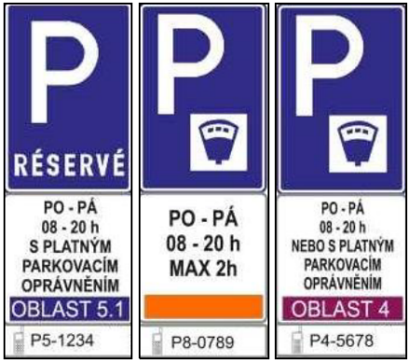Areas for visitors are recognizable only by a lack of blue line and a traffic sign (picture to the right) at its beginning. Zone’s characteristics are defined by a color (blue, violet or orange), which is designated by appropriate ribbon at the bottom of the sign. The characters below the ribbon define the name of the particular zone.

Orange zone allows you to park only for two hours, purple zone is long term. Payment is possible by parking meter (on the spot) or via web (<https://ke-utc.appspot.com/static/select.html?label=PRAHA>). For web payment you need to know the name of your particular zone (bottom line on a traffic sign, e.g. P4-5678). Distribution of the zones can be seen on [www.mapy.cz](http://www.mapy.cz) when the area of interest is properly magnified (blue and violet contours on the streets).

To make it more complicated there are slightly different rules and prizes throughout Prague... All details can be found on municipal webpage (<http://www.parkujvklidu.cz/prague-parking/>), but the contents is very confusing. We personally are glad that as locals we don’t have to undergo this procedure and are sorry for you.

#### Public transportation

Public transport is comfortable and convenient during the whole day and night. Subway operates from 06:00 almost to midnight, trams and buses from app 05:00 till 0:30. Night service is from midnight till 05:30. Fare is still the same. You can buy any ticket in the subway vestibule in vending machine, most common tickets in any newspaper stand. Some trams also offer online ticket sale by card.

**Please acknowledge that buying ticket is not enough!** After entering the bus or tram or the area before escalators to subway, you have to punch the ticket in a yellow machine – indicating the entry time. Then it is valid for the time indicated in chart below and also on the ticket itself. In due time you can arrange your trip as you wish, change how many times you wish – you don’t have to punch your ticket in every boarded tram if it’s still in the valid time frame!

People above 65 years and children under 15 years can travel inside Prague for free as long as they can prove their age (e.g with passport). Bikes are allowed in subway in last door of last coach and you don’t need the ticket for bike transport. All details of the schedules, lines, fares and exceptions in operations can be found here – [www.dpp.cz](http://www.dpp.cz) (also an app for iOS and Android). There you can also find the best connection.

#### Taxi

Common taxis are better to be avoided – in this sense we’re still Wild East and you never know how much you’d eventually pay for the ride with the driver who’s rude and not speaking anything except Czech. Instead you may use Uber, Bolt or local variety Liftago. All have mobile app available and reasonable prices known in advance.

## Highlights worth visiting

Historical sites in Prague center are numerous and better described in any guide so I’ll omit most of them. Below are the sites or tracks which are usually not so crowded by tourists.

#### Břevnovský klášter (Břevnov Monastery)

([www.brevnov.cz](http://www.brevnov.cz)) is one of the oldest in Czech Republic (founded in 10th century) and has beautiful garden and its own craft brewery. In June you can taste cherries growing in the upper garden.

#### Nový svět and Jelení příkop

Small historical houses off the track close to Prague Castle and a castle moat. Start at tram / bus stop Vozovna Střešovice. Cross the main street to a small park and proceed through the park. You come to a sharp turn in another main street with trams. When you cross this street (there on the spot) slightly to the left are stairs going down. That’s it, go down.

If you proceed further straight ahead, you get to baroque church Loreta with its “singing” bells and the “main” road to Prague Castle.

Then If you go around Loreta taking left side, eventually you’d get to the main Castle entrance from the backyard. On the way there, once you clear the wall on the left side and are on a crossing, across the street is a side entrance to north side Castle gardens accessible by moat. You can proceed all the way along the Castle. At the end of the moat you can either turn left to reach Belvedere and gardens or right to exit by Malostranská subway station.

#### Petřín

Hill above historical center with lookout in shape of Eiffel Tower. Nearby is a mirror maze, rose garden and observatory. The most magnificent visit is to take the funicular from Újezd (tram 20 from Bořislavka), but this ride is really popular so expect really long waiting. After climbing the tower etc. continue along the slope (don’t cross the wall again) to Strahovský klášter and further to Loreta or Prague Castle. This way you can enjoy beautiful views and scenery and in right season also enjoy cherries.

#### Museum of public transportation

(<http://www.dpp.cz/muzeum-mhd>) Showing old trams, buses etc. Here is also the start of historic tram line 41 (https://www.dpp.cz/en/entertainment-and-experience/dpp-history/historical-line-no-41) which you can use for sightseeing in Old Town because stops along its route are numerous. Tickets are sold by the driver.

#### Waste water treatment plant (<http://www.stara-cistirna.cz/>) and Stromovka

Original steam-engine equipped plant from year 1904 (still functional engines!) with beautiful brickwork.

The plant is located in most western corner of big park called Stromovka which is popular for cycling and roller skating. Skates are for rent at Šlechtova restaurace in the middle of the park. At the eastern side is Planetarium with good shows ([www.planetarium.cz](http://www.planetarium.cz)).

#### ZOO (<https://www.zoopraha.cz>) and tropical greenhouse (http://www.botanicka.cz)

Prague ZOO is big, rich with animals and you can easily spend the whole day there. It’s famous for its wild horses (Equus Przewalski) herd because of successful breeding of them. Several horses were released back to their original biotope - steppe in Mongolia where they were already extinct. You can shorten the way inside ZOO by funicular.

Tropical greenhouse is a part of botanical garden, which is next to the ZOO.

There are three ways how to get there:

Boring – get subway to Muzeum, change for red line C and go to Nádraží Holešovice. Then continue with bus 112 to the ZOO.

Interesting – get any bus going to V Podbabě (i.e. 107, 147, 160). Close to that stop on the right side is a very small ferry (your ticket is valid there!). 100m from the river on the other bank is a bus stop (112, 236) and the ZOO is just three stops. On the way you may see giraffes and some goats behind the fence.

Leisure – get a walk through Stromovka and follow the signs to the ZOO). En route you’ll pass a baroque chateaux (<http://trojskyzamek.cz/>) with a nice garden. Inside is a gallery.

#### Gardens in the old town

***Valdštejnská zahrada*** – entrance is right at the subway exit in Malostranská (immediately to the right). It’s beautiful with awesome view on the castle, artificial cave, pond with fish and several peacocks. Its convenient location attracts tourists, but it’s calm anyway.

***Vojanovy sady*** – if you stand at Malostranská station, facing away from the castle, with tram stop and park on your left side, cross the street on traffic lights straight ahead to the only street which doesn’t have tram tracks (parallel to the river). After app 100 meters you’d pass along the wall on the right side. When you find the gate, that’s entrance to Vojanovy sady.

At the beginning of the wall there’s a small clearing which touches a river bank. That’s also a nice quiet place.

***Františkánská zahrada*** – if you want to rest a while in the centre of the metropolis, there’s a chance. Františkánská zahrada is a small quiet place connecting Jungmannovo náměstí (yellow line B station Můstek) with Václavské náměstí (green line A station Můstek) and running alongside the latter until the tram lines crossing Václavské náměstí in the middle. Right at the tram stop is a cinema and passageway Světozor. There’s a well-known sweetshop Světozor with great sorbets and ice creams. Once you go to the end of that passageway the view opens into the garden (with children playground).

### Near surroundings

#### In-line skating

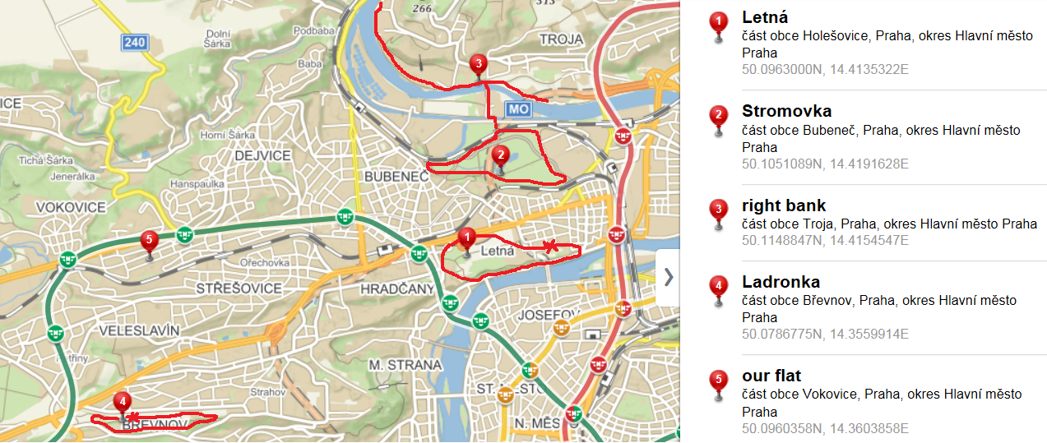We don’t have any in-line skates, but most of the places described below offer the rent (at least did before Covid). There are several areas well suited for in-line skating, highlighted on the map. But as all popular sites they become crowded during weekends. Also beware of small kids and moms with strollers.

Blue stars represent Hotel International and Masarykova kolej.

1 – Accessible by tram 26 from Thákurova or 8 from Podbaba (stop Letenské náměstí). Skate rental is in the garden of National Agricultural Museum (marked with red star). There are numerous stalls selling beer and refreshments in the park. The whole area has beautiful view on historical centre.

2 – Big park with many quiet corners. There used to be skate rentals in the restaurant Šlechtovka in the middle of the park but we’re not sure if it’s still operating.

3 – Maybe the best area for in-lines covered with small pubs and stalls, thus favorite and crowded during the weekends. It’s also well connected with Stromovka. This track goes around Troja chateau and the ZOO (mentioned in previous chapter)